REVIEW III

# Database Design

## Database Relationship Diagram (DRD)

## Database Structure

### Table: admin

| Field | Type | Null | Key | Default | Extra | Comment |
| --- | --- | --- | --- | --- | --- | --- |
| username | VARCHAR(32) | NO | PK | (NULL) |  |  |
| Password | VARCHAR(32) | NO |  | (NULL) |  |  |

### Table: contact

| Field | Type | Null | Key | Default | Extra | Comment |
| --- | --- | --- | --- | --- | --- | --- |
| contact_id | INT | NO | PK |  | IDENTITY(1,1) |  |
| contact_name | VARCHAR(255) | NO |  |  |  |  |
| contact_email | VARCHAR(255) |  |  |  |  |  |
| contact_subject | VARCHAR(255) |  |  |  |  |  |
| contact_message | TEXT(1000) |  |  |  |  |  |
| contact_reply | TEXT(1000) |  |  |  |  |  |
| contact_status | TINYINT | NO |  | 0 |  | 0: Unread  1: Read  2: Replied |
| contact_date | DATETIME |  |  |  |  |  |
| reply_date | DATETIME |  |  |  |  |  |

### Table: faqs

| Field | Type | Null | Key | Default | Extra | Comment |
| --- | --- | --- | --- | --- | --- | --- |
| faq_id | INT | NO | PK |  | IDENTITY(1,1) |  |
| question | VARCHAR(255) |  |  |  |  |  |
| answer | TEXT(1000) |  |  |  |  |  |

### Table: feedbacks

| Field | Type | Null | Key | Default | Extra | Comment |
| --- | --- | --- | --- | --- | --- | --- |
| feedback_id | INT | NO | PK |  | IDENTITY(1,1) |  |
| user_id | INT | NO | FK |  | users.user_id |  |
| subject | VARCHAR(255) |  |  |  |  |  |
| message | TEXT(1000) |  |  |  |  |  |
| reply | TEXT(1000) |  |  |  |  |  |
| status | TINYINT | NO |  | 0 |  | 0: Unread  1: Read  2: Replied |
| feedback_date | DATETIME |  |  |  |  |  |
| reply_date | DATETIME |  |  |  |  |  |

### Table: collections

| Field | Type | Null | Key | Default | Extra | Comment |
| --- | --- | --- | --- | --- | --- | --- |
| collection_id | INT | NO | PK |  | IDENTITY(1,1) |  |
| title | VARCHAR(255) |  |  |  |  |  |
| status | TINYINT |  |  | 0 |  |  |

### Table: users

| Field | Type | Null | Key | Default | Extra | Comment |
| --- | --- | --- | --- | --- | --- | --- |
| user_id | INT | NO | PK |  | IDENTITY(1,1) |  |
| name | VARCHAR(255) | NO |  |  |  |  |
| username | VARCHAR(32) | NO |  |  | UNIQUE |  |
| password | VARCHAR(32) | NO |  |  |  |  |
| email | VARCHAR(255) | NO |  |  | UNIQUE |  |
| address | VARCHAR(255) | YES |  |  |  |  |
| gender | BIT | NO |  | 0 |  |  |
| birth_year | VARCHAR(4) |  |  |  |  |  |
| user_status | TINYINT | NO |  | 0 |  | 0: Pending  1: Approved  2: Declined |
| reset_password_key | VARCHAR(32) | YES |  |  |  |  |
| join_date | DATETIME |  |  |  |  |  |

### Table: images

| Field | Type | Null | Key | Default | Extra | Comment |
| --- | --- | --- | --- | --- | --- | --- |
| image_id | INT | NO | PK |  | IDENTITY(1,1) |  |
| title | VARCHAR(255) | NO |  |  |  |  |
| user_id | INT | NO | FK |  | users.user_id |  |
| collection_id | INT | NO | FK |  | collection.collection_id |  |
| description | TEXT(1000) |  |  |  |  |  |
| filename | VARCHAR(255) | NO |  |  |  | File name of image |
| path | VARCHAR(255) | NO |  |  |  | Location of image |
| share_status | TINYINT | NO |  |  |  | 0: Private  1: Friend  2: Public |
| upload_date | DATETIME |  |  |  |  |  |
| modify_date | DATETIME |  |  |  |  |  |

### Table: comments

| Field | Type | Null | Key | Default | Extra | Comment |
| --- | --- | --- | --- | --- | --- | --- |
| comment_id | INT | NO | PK |  | IDENTITY(1,1) |  |
| image_id | INT | NO | FK |  | images.image_id |  |
| comment | TEXT(1000) |  |  |  |  |  |
| comment_date | DATETIME |  |  |  |  |  |

### Table user_friends

| Field | Type | Null | Key | Default | Extra | Comment |
| --- | --- | --- | --- | --- | --- | --- |
| friend_id | INT | NO | PK |  | IDENTITY(1,1) |  |
| user_id | INT | NO | FK |  | users.user_id |  |
| friend | INT | NO | FK |  | users.user_id |  |
| request_status | BIT | NO |  | 0 |  | 0: Requested  1: Approved |
| comment_date | DATETIME |  |  |  |  |  |

## Database Constrains

### Table: users

Constraint:

* UNIQUE: username must be unique
* UNIQUE: email must be unique

|  |  |  |  |
| --- | --- | --- | --- |
| Name | Add | Delete | Update |
| users | +  (username)  (email) | - | +  (username)  (email) |

### Table: feedbacks

Constraint:

* FOREIGN KEY: user_id must exist

|  |  |  |  |
| --- | --- | --- | --- |
| Name | Add | Delete | Update |
| feedbacks | +  users.user_id  must exist | - | +  users.user_id  must exist |

### Table: images

Constraint:

* FOREIGN KEY: user_id must exist
* FOREIGN KEY: collection_id must exist

|  |  |  |  |
| --- | --- | --- | --- |
| Name | Add | Delete | Update |
| images | +  users.user_id  must exist  collections.collection_id must exist | - | +  users.user_id  must exist  collections.collection_id  must exist |

### Table: comments

Constraint:

* FOREIGN KEY: image_id must exist

|  |  |  |  |
| --- | --- | --- | --- |
| Name | Add | Delete | Update |
| comments | +  images.image_id  must exist | - | +  images.image_id  must exist |

### Table: user_friends

Constraint:

* FOREIGN KEY: user_id must exist
* FOREIGN KEY: friend must exist

|  |  |  |  |
| --- | --- | --- | --- |
| Name | Add | Delete | Update |
| user_friends | +  users.user_id  must exist  users.user_id  must exist | - | +  users.user_id  must exist  users.user_id  must exist |

# GUI Designs – Front-End

# GUI Design – Back-End

## Login

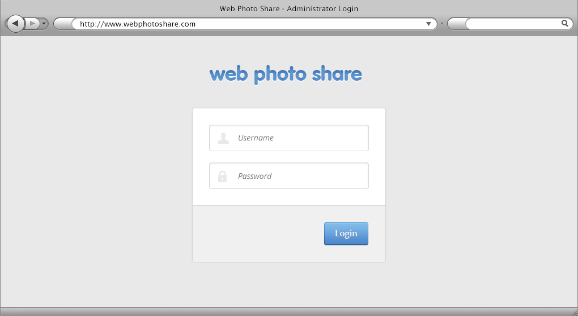

|  |  |  |  |  |  |  |
| --- | --- | --- | --- | --- | --- | --- |
| No. | Name | Type | Validation | Event | Description | Status |
| 1 | txtUsername | Textbox | Not null |  | Username of User | Enable |
| 2 | txtPassword | Textbox (Mode Password) | Not null |  | Password of User | Enable |
| 3 | btnLogin | Button |  | Click | Process Login Request | Enable |

## Dashboard

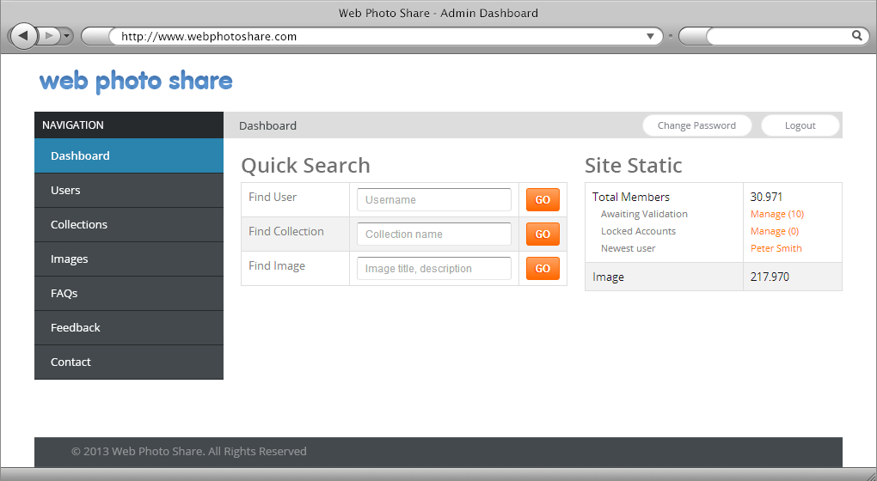

|  |  |  |  |  |  |  |
| --- | --- | --- | --- | --- | --- | --- |
| No. | Name | Type | Validation | Event | Description | Status |
| 1 | txtUsername | Textbox | Not null |  | Username of User | Enable |
| 2 | txtCollectionName | Textbox | Not null |  | Collection Name | Enable |
| 3 | txtImage | Textbox | Not null |  | Image Title ,Description | Enable |
| 4 | btnGo | Button | Click |  | Search | Enable |

## User-Manage

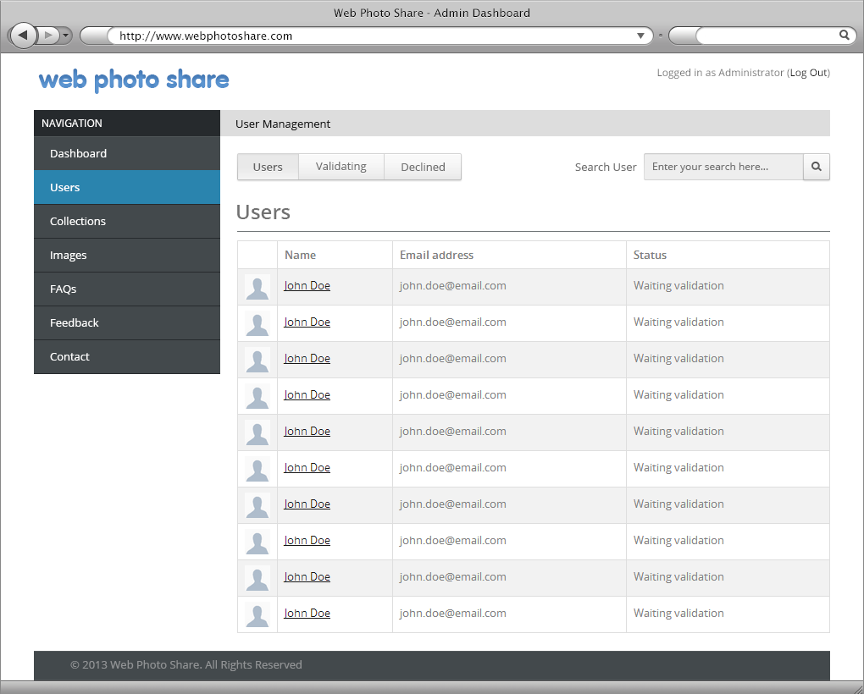

|  |  |  |  |  |  |  |
| --- | --- | --- | --- | --- | --- | --- |
| No. | Name | Type | Validation | Event | Description | Status |
| 1 | txtSearch | Textbox | Not null |  | Search Users | Enable |
| 2 | btnSearch | Button | Not null | Click | Process Search Request | Enable |
| 3 | User,Validating,Declined | Menu |  |  |  | Enable |

## User-Manage-Declined

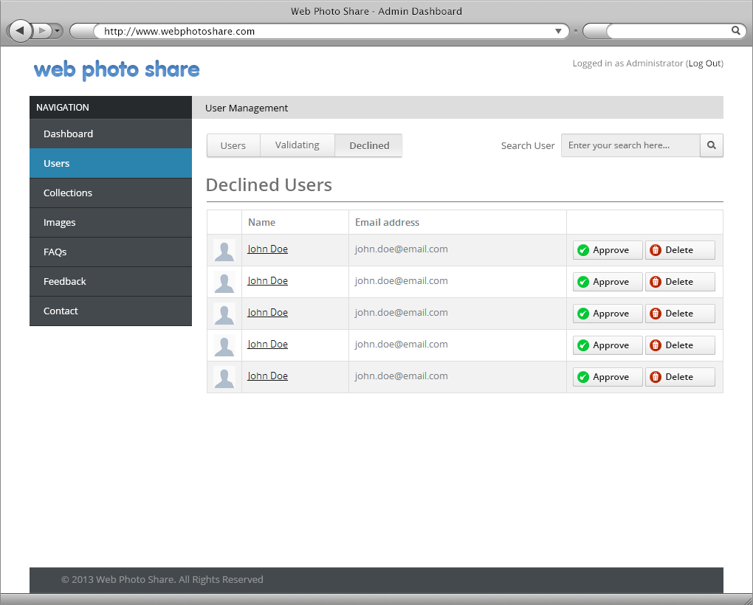

|  |  |  |  |  |  |  |
| --- | --- | --- | --- | --- | --- | --- |
| No. | Name | Type | Validation | Event | Description | Status |
| 1 | txtSearch | Textbox | Not null |  | Search Users | Enable |
| 2 | btnSearch | Button | Not null | Click | Process Search Request | Enable |
| 3 | User,Validating,Declined | Menu |  |  |  | Enable |
| 4 | btnApprove | Button |  | Click | Approve User | Enable |
| 5 | btnDelete | Button |  | Click | Delete User | Enable |

## User-Manage-Edit

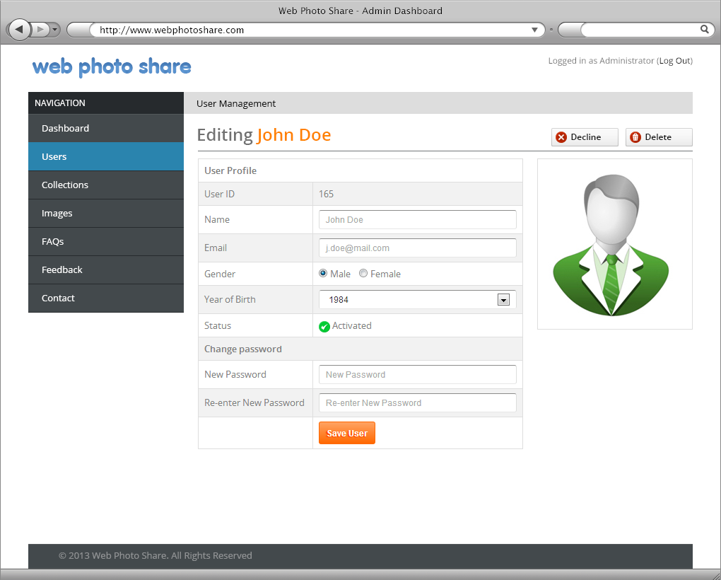

|  |  |  |  |  |  |  |
| --- | --- | --- | --- | --- | --- | --- |
| No. | Name | Type | Validation | Event | Description | Status |
| 1 | txtUserId | Textbox | Not null |  | UserId | Disable |
| 2 | txtUserName | Textbox | Not null |  | UserName | Enable |
| 3 | txtEmail | Textbox | Not null |  | Email | Enable |
| 4 | radGender | RadioButton |  | Click | Gender(Male,Female) | Enable |
| 5 | cboYearOfBirth | Combobox | Not null |  | Year Of Birth | Enable |
| 6 | txtNewPassword | Textbox |  |  | New Password | Enable |
| 7 | txtReNewPassword | Textbox |  |  | Re-Enter New Password | Enable |
| 8 | btnSave | Button |  | Click | Save User Edit | Enable |
| 9 | btnDecline | Button |  | Click | Decline User | Enable |
| 1o | btnDelete | Button |  | Click | Delete User | Enable |

## User-Manage---Validating

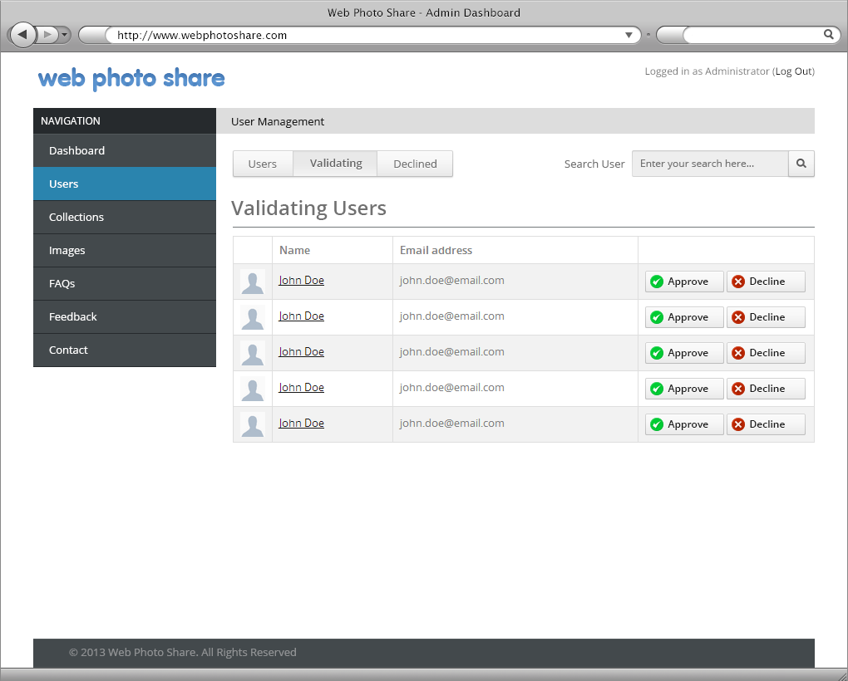

|  |  |  |  |  |  |  |
| --- | --- | --- | --- | --- | --- | --- |
| No. | Name | Type | Validation | Event | Description | Status |
| 1 | txtSearch | Textbox | Not null |  | Search Users | Enable |
| 2 | btnSearch | Button | Not null | Click | Process Search Request | Enable |
| 3 | User,Validating,Declined | Menu |  |  |  | Enable |
| 4 | btnApprove | Button |  | Click | Approve User | Enable |
| 5 | btnDelete | Button |  | Click | Delete User | Enable |

# Sitemap

## Front-End Sitemap

## Back-End Sitemap

# Task sheet review 3

|  |  |  |  |  |  |
| --- | --- | --- | --- | --- | --- |
| Project Ref. No: 2 | Project Title: | Date of Preparation of Activity Plan | | | |
| No. | Task | Actual Start Date | Actual Days | Team Member Name | Status |
| 01 |  | May 04, 2013 | 10 |  |  |
| 02 |  |  |  |
| 03 |  |  |  |
| 04 |  |  |  |

|  |  |  |
| --- | --- | --- |
|  | Prepare By: Group | Approved By: Faculty |
| Date: | Team Leader  Nguyen Vu Hung |  |